**Word Dictionary**

**Problem Statement -**

Write a program to create and use a word dictionary. The key functionalities would include

* API to create and persist a word dictionary by uploading a text file having few paragraphs (file Size Max: 200 MB).
* User should be able to search if a given word is available in the dictionary
* Creation of UI is optional

**Solution –**

The solution is in C#.Net and a windows form application is created. Below is the snapshot of how the application looks.

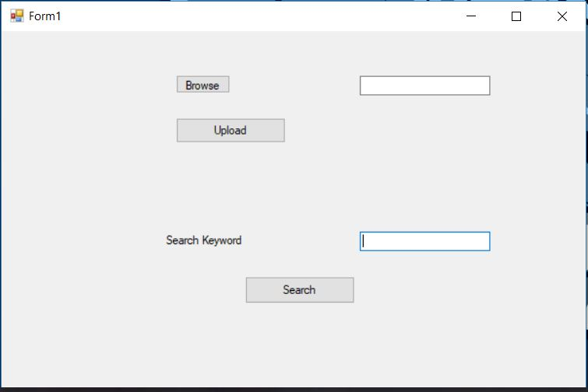

1. First, we browse the text file that we need to upload for creating a persisting word dictionary.

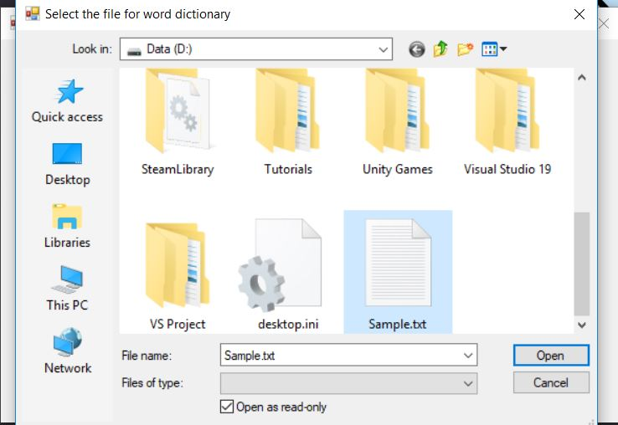

2. After selecting the file, we will upload it which at the back end appends the current text file’s contents into our word dictionary text file.

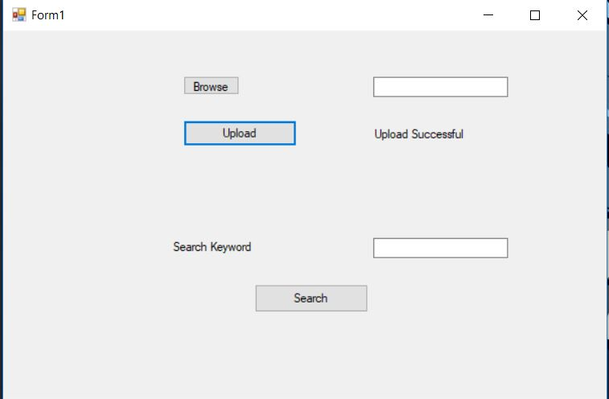

3. Now if we want to search we can put the search text into the search keyword text box.

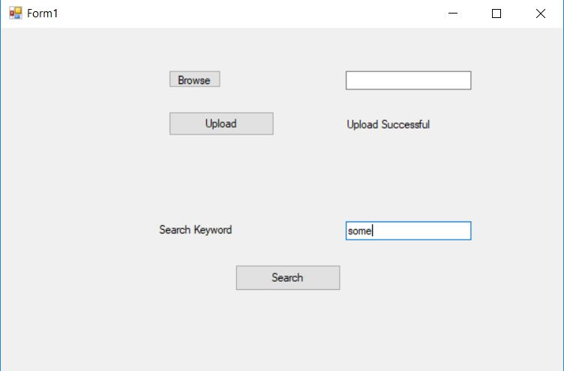

4. After entering the word, we can search it using the search button which will give us the desired result.

